Calcuclock – Assembly Guide

First, you will need to solder the resistors. Pay careful attention to the resistor values – if they are incorrect, the device will not work correctly, and in some cases may even damage components. Note that some of the pads are smaller than others – in particular, the pads on the 100-ohm resistors are quite small, and so won’t require as much solder as the others.

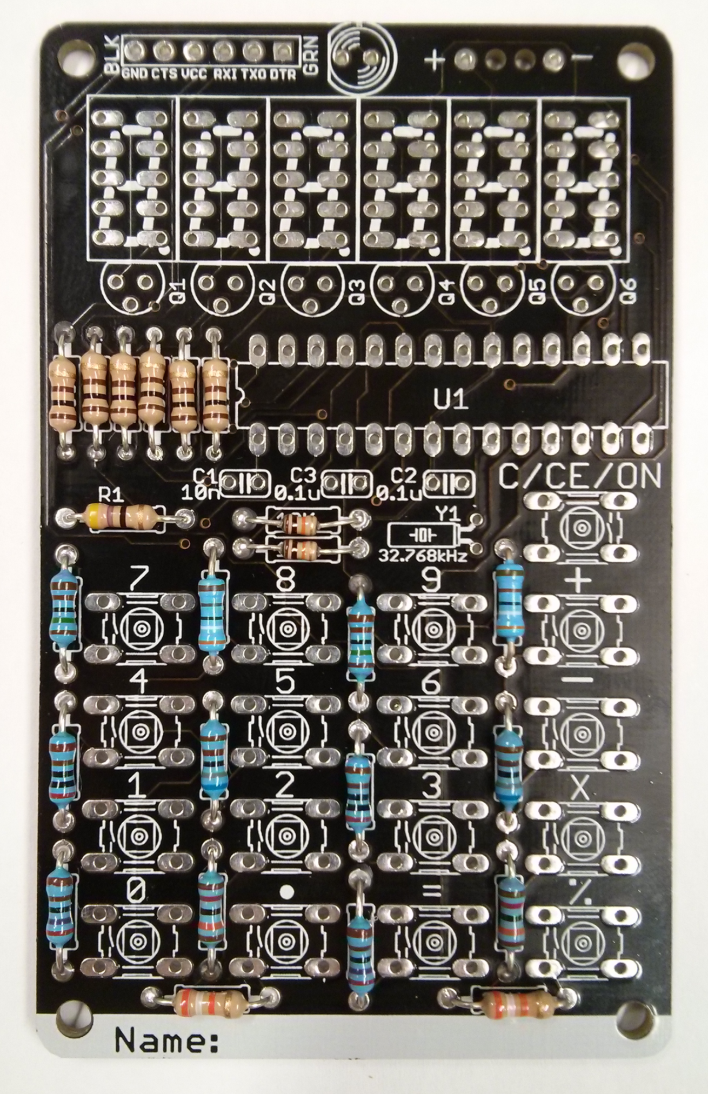

47R – Yellow, Violet, Black

100R – Brown, Black, Brown

10K – Brown, Black, Orange (smaller)

1.5K – Brown, Green,…

2K – Red, Black,…

2.7K – Red, Violet,…

3.9K – Orange, White,…

6.8K – Blue, Grey,…

13K – Brown, Orange,…

39K – Orange, White, Orange

Higher-precision resistors (1% - blue body, brown tolerance) have 5 colour bands not 4. They are read in a similar way to 5% resistors (Val, Val, Val, Num Zeros, Tolerance).

Ground

Then, solder the 32.768kHz crystal Y1 (the small, shiny metal can with two thin, delicate wires). Be careful not to over-heat it, bend the wires too far, or put too much solder on the pads. You should use a multimeter at this point, to ensure that the pins of the crystal (which join to pins 19 and 20 on the chip) aren't shorted together or to ground (as indicated above).

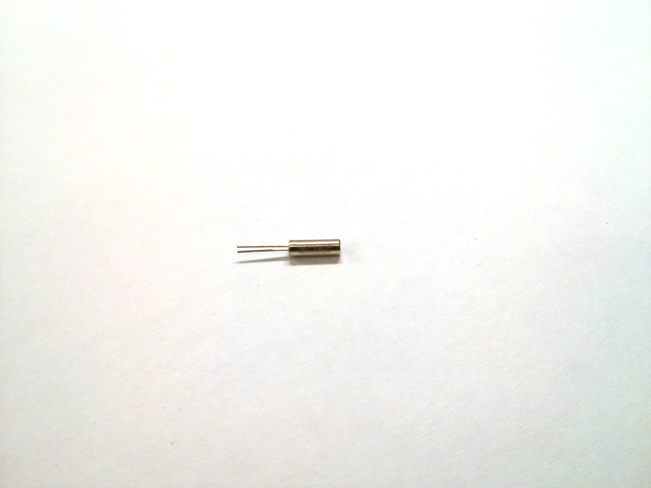

Next, solder the chip socket in place (do NOT solder the chip itself in - otherwise if something goes wrong, you won't be able to replace the chip!). Note that one side of the chip socket has a notch, which should correspond with the notch on the silkscreen image on the PCB. This tells you which way around the chip needs to go.

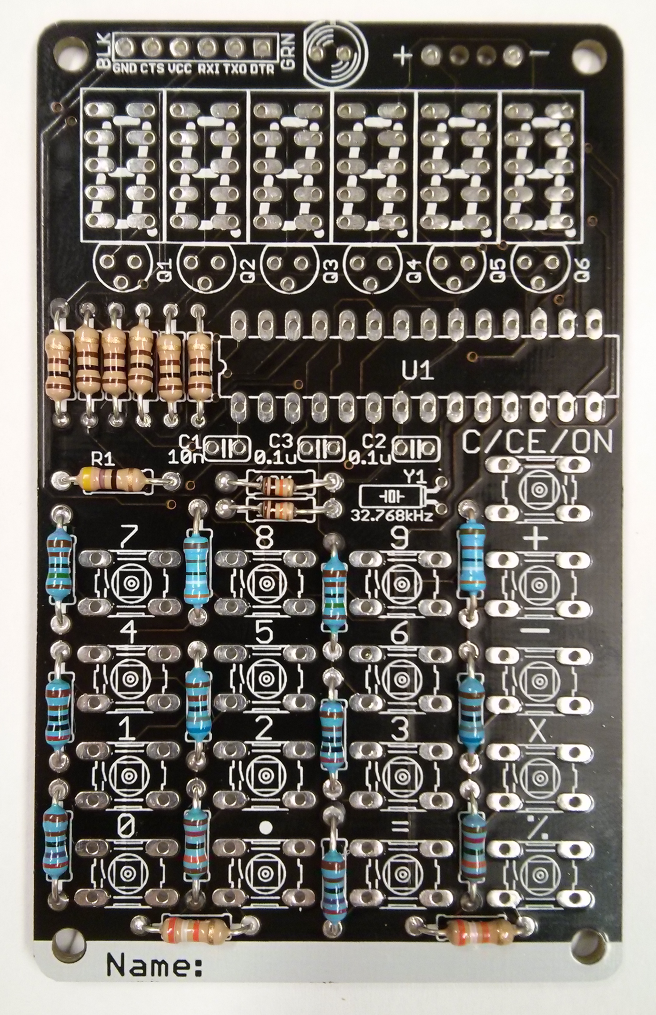

The notch on the chip socket should line up with this notch

Next, clip in and solder the 17 switches. They will need to be pressed firmly down before soldering - make sure they're completely flat. The switch’s legs are sharp, and need a fairly large amount of force to sit flat, so take care when installing them or else you might hurt yourself. Also take care not to bend any of the switch's legs.

After this, you may want to solder in the 6-pin right-angled header. This allows you to connect your calculator to the computer, and download new code to it. The calculator will work if you leave this header out, but you will be unable to download any new code to the chip without it. It's recommended that you tape the header in place before soldering, or rest it on a flat surface - otherwise it is easy to burn yourself, because the heat conducts rapidly down the metal pins.

Next, solder the 6 seven-segment displays, and transistors Q1-Q6. They must be installed in the correct orientation – the decimal places should be in the correct position (near the transistors), and the transistors should be placed with the flat side nearest the 7-segment displays. It is recommended that you solder one pair of pins (a diagonal pair) on each of the 7-segment displays, and ensure that the displays are all straight and pressed flat against the PCB before soldering the remaining 8 joints. It's much easier to correct a mistake or misalignment involving just 2 pins than it is to fix a mistake with all 10!

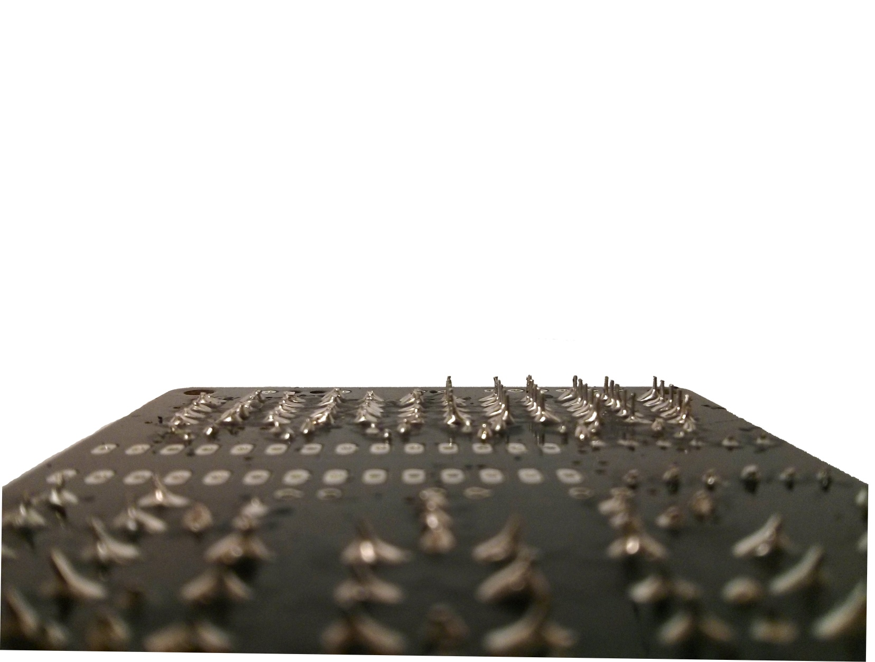

Trim the legs off close to the PCB when you've finished (as done on the left hand half of the above photo).

Finally, solder the IR LED, and battery box. The IR LED and battery box are both polarised, and the IR LED should be pointed forwards – the light is only emitted in a narrow cone shape, so will need to point towards the TV you’re trying to switch off. The battery box's wires can be threaded through the two holes in the centre. This helps reduce the strain on the solder joint.

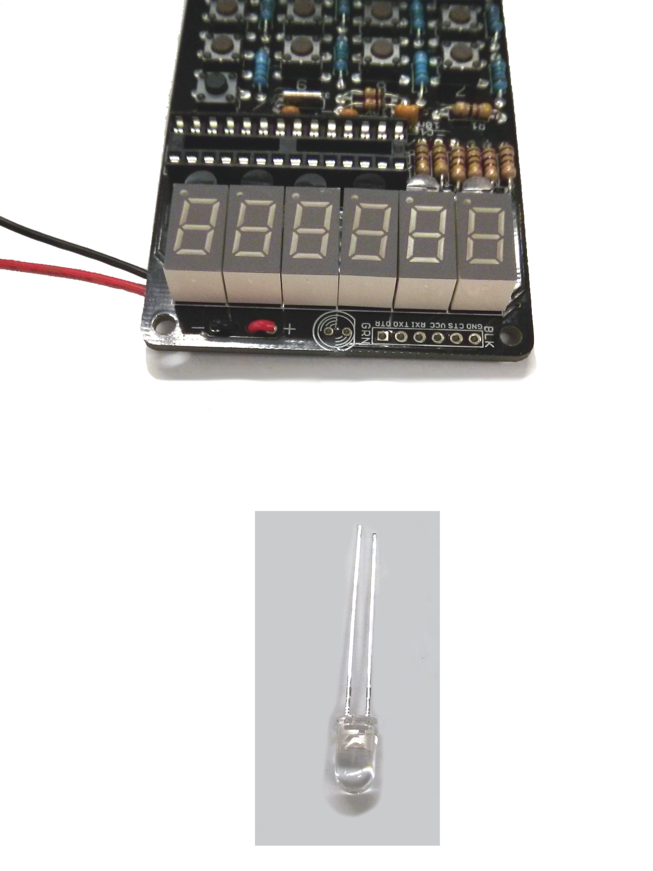

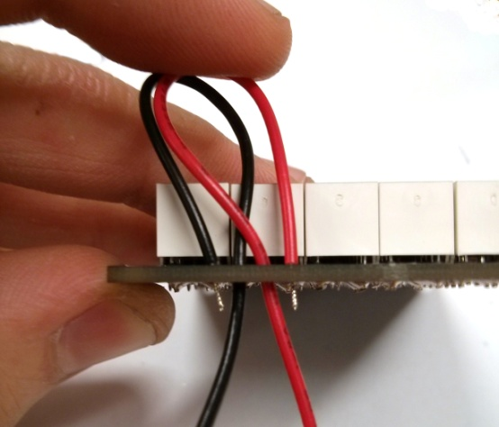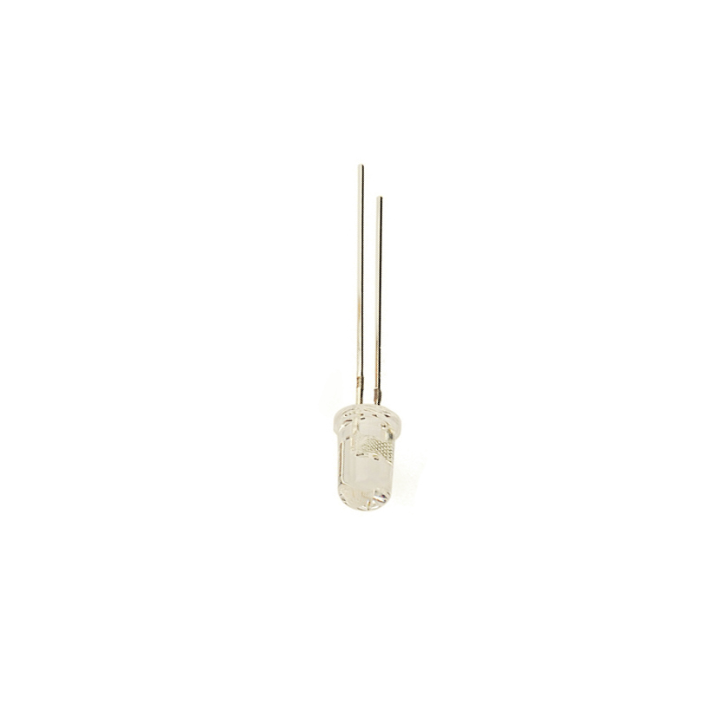

The orientation of the LED is important - note the shorter leg of the LED is negative, and so goes on the right, as seen in the image. The flat side of the LED should line up with the flat side on the PCB silkscreen.

Also note that the LED should shine forwards rather than straight upwards - you should bend it in to the correct position before soldering.

After finishing the soldering, let your teacher or a technician check your soldering. Once they are happy, they will put a pre-programmed IC in the chip socket. Just add batteries, and your calcuclock should be ready to use. It should display a date and time when the C/CE/ON button is pressed.

Your IC comes pre-programmed to run as both a calculator and a clock. The chip will come pre-programmed with the finished code – try it out and make sure that the display and buttons all work as expected. If anything doesn’t work, disconnect the batteries and look at the fault-finding guide.

Fault-Finding

Problems after soldering:

**Nothing lights up when I press the ON button:** Do you have the IC installed correctly – notch on the left, no bent pins, pushed down firmly and evenly? Are the batteries installed correctly? Are the transistors the right way around, with the flat side nearest the 7-segment displays? If this doesn't solve the problem, remove the batteries, and show your teacher or a technician.

**One of the 7-segment displays doesn't light up:** Look at the resistors to the left of the IC. Are they all the correct value (100R - Brown, Black, Brown, Gold)? Are they soldered correctly? Look at the corresponding resistor and check to see that the solder joint has been made correctly. Next, check that the corresponding transistor - is it soldered correctly? Is it the right way around? If not, ask your teacher or a technician.

**The display doesn't show a correct pattern/too many segments are lit/some are brighter than others:** Check that none of the resistor or transistor pins are bridged together with solder. Also check the pins of the IC.

**The time doesn't count up - it's stuck at one time:** Show the technician or teacher. This issue will likely relate to the soldering near the very delicate 32.768kHz crystal. They should use a multimeter to check to see whether pins 9 and 10 on the IC are shorted to each other or to ground.

**One of the segments isn’t lighting up:** Check the transistor that corresponds to that 7-segment display, and the solder joints on the display. Look for a weak solder joint or lifted trace. Also check the corresponding 100R resistor.

**One key isn’t working correctly:** Check that the corresponding switch is soldered in place correctly. Check that the resistors nearby are also soldered correctly.

**Half of/the entire keypad isn’t reporting the correct value, or isn’t responding when pressed:** Check the resistor values, and the soldering around the keypad. Also check the 10K resistors, and pins 23 and 24 on the chip.

**The device thinks that a button is being pressed, even when it isn’t:** Check for solder bridges in and around the relevant button. Check the 10k pullup resistors are soldered correctly and not bridged to each other or to ground, and that pins 23 and 24 on the chip aren’t bridged or shorted to ground. If you have a multimeter, check the continuity from the button to ground (labelled on the FTDI header). Two of the 4 pins on the button should have continuity to ground, the other two should not unless the button is being pressed.

**I can’t program my device:** Check that the programming header, pins 26, 27 and 28 on the chip, and the capacitors are soldered correctly. If the calculator works correctly other than programming, follow the “Problems whilst programming” guide.

Problems whilst programming:

**avrdude: stk500_getsync(): not in sync: resp=0x00**

This error occurs when the computer is trying but failing to talk to the device. Check:

* Is the device in sleep mode? Make sure the calculator is switched on fully when you are trying to upload the code – it won’t reliably program if in sleep mode.
* Are the batteries installed correctly in the calculator?
* Did you choose the correct COM port? The calculator is not on COM1 – programming with COM1 selected may produce this error.
* Is the header connected the right way around, and pushed in fully?
* Are the batteries flat?
* Have you selected the correct board in the Tools -> Board menu?

**"Serial port 'COMXX' not found. Did you select the right one from the Tools -> Serial Port menu?"**

This might happen if the cable is unplugged, or you’re using a different computer to the one that you wrote the sketch on.Try plugging the cable in, closing and re-opening the Arduino software, then choosing the correct COM port in the menu.

Programming the calcuclock:

Connect the FTDI cable to the computer, and the device – make sure that you connect the cable the correct way around. The green wire should be on the right-hand side when viewed from the front.

Open the Arduino IDE, select “Arduino Pro or Pro Mini (3.3V, 8Mhz) w/ ATmega328” and choose the highest-numbered COM port (typically COM19 or COM20, but may vary from computer to computer).

Load the example code from the Examples menu, and click “Upload”. It should say "Compiling Sketch", then "Uploading", then finally "Done uploading".

Programming at home:

The cable used is a FTDI cable, and can be purchased from SparkFun electronics, or through one of their resellers such as proto-pic: <http://proto-pic.co.uk/usb-to-serial-ttl-cable-ftdi-5v-vcc-3-3v-i-o/>. Make sure you choose a 3.3v version, not a 5v version.

The Arduino IDE is free software and can be found for Windows, OS X and Linux at [www.arduino.cc](http://www.arduino.cc)

The code can be copied freely from <https://github.com/charliebruce/calcuclock-sw>

Beginning to Program

Programming the clock/calculator from scratch would be fairly challenging without completely understanding the low-level functionality of the chip and the circuit, and researching the rules that determine how leap years and daylight-saving time works. For this reason there is a set of “helper” code provided that handles date/time logic, and the low-level code such as writing numbers to the display, reading the keypad, and managing the time. See the example programs in the “Calcuclock” sub-menu in the Examples menu of Arduino IDE for examples of how to do each.

Technical details:

There are several tricks in place to make the board smaller and simpler. The first trick is that the buttons aren’t connected individually to the chip – they connect via a “ladder” of resistors which form a potential divider, which varies a voltage, depending on which button is pressed. This means that all 16 buttons connect via just 2 pins on the chip, and can be read using an analog-to-digital read. In theory many more buttons could connect to the chip in this way (1023 buttons) but in practice, the precision of the analog-to-digital conversion and the tolerance of the resistors stops this from being possible.

The 7-segment displays are also wired in a specific way, so that a lower-pin-count chip can be used. Instead of each pin of each 7-segment display being connected directly to the chip, each segment of each device is connected to a single pin on the IC, and each anode is connected to another pin via the PNP transistor. To show the pattern, the chip quickly switches the segments into their correct states, then switches the first transistor on. After a short time, it switches the transistor off, switches the segments to the next display’s state, then switches the second transistor on. It repeats this for each display in a loop – this is done so fast that the human eye doesn’t see the “off” time – a phenomenon called persistence of vision. To confirm this, you can look at the code, move the device around very quickly in a dark room, or take a very short-exposure photo of the display in a darkened room, using a camera with manual exposure. You’ll need to use around 1/250, 1/500, 1/1000 or 1/2000 exposure – the display updates once every 6 milliseconds, so any slower shutter speed will hide the effect in the same way that your eye does.

The on button is "soft" - it doesn't actually connect power to the chip, otherwise the time would stop counting when the calculator is off. Instead, the chip goes into a very deep sleep mode until the button is pressed. In this deep sleep mode, nearly all of the chip is switched off - the only things active are one of the timer modules (keeping track of real time), and the interrupt-detection circuitry (the ON button uses this feature to switch the chip back on fully). The CPU, memory, other timers, output pins, brown-out detection, ADC and watchdog timers are all switched off, because they draw power and aren’t actively being used. One disadvantage of this is that the chip might perform oddly at very low voltages, such as those found when the batteries are fully drained.

Extension activities, sources

The calcuclock also has an IR LED installed, which can be used to switch TVs and other devices off. The code to do this is freely available, and is called “TV-B-Gone”.

The remainder of the code has been written from scratch, though SparkFun’s guide “[Adventures in Low-Power Land](https://www.sparkfun.com/tutorials/309)” was useful when working out which settings could be chosen, and power-saving options could be used to get the current draw down to an absolute minimum. The bootloader is similarly taken from a SparkFun kit, but is based on open-source software.

Schematic

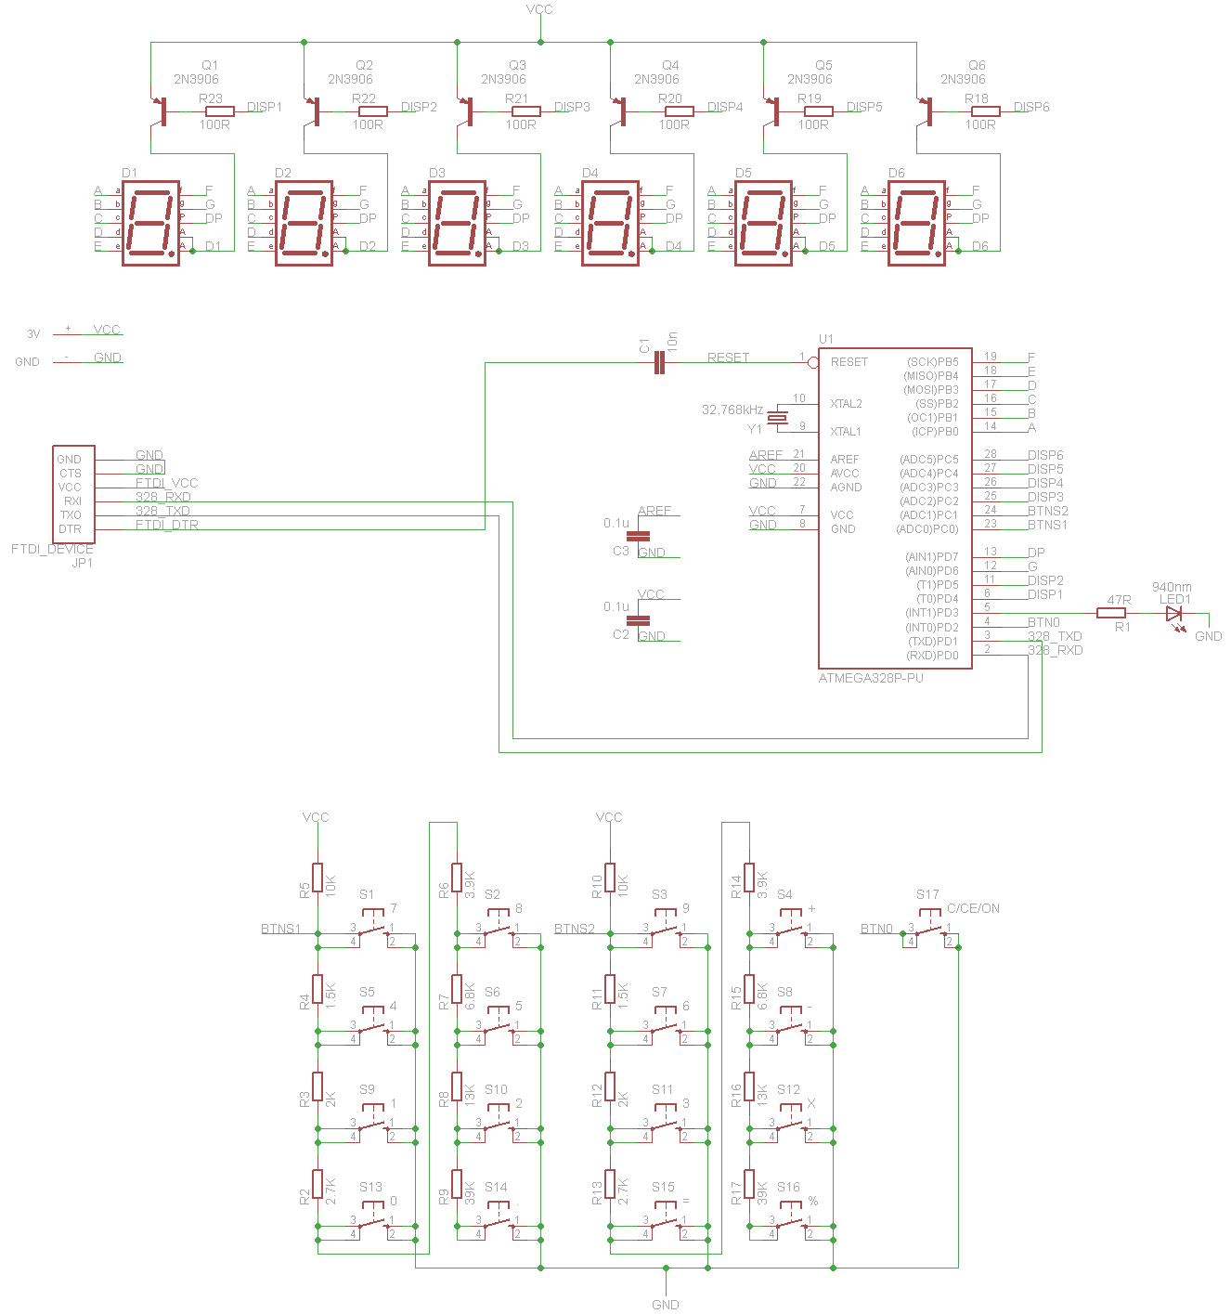

Important Note

When soldering you should use the bare minimum amount of solder, to reduce the chance of pins being shorted together. It’s easier to fix a cold joint caused by insufficient solder than it is to find and remove short-circuits.

Some components must be installed in one specific orientation – specifically the chip, chip socket, transistors, 7-segment displays, LED, battery wires, and programming header. The remaining components are not polarised and can be installed in two different orientations.

Attribution

LED image (page 3) by SparkFun Electronics.